ACSL
American Computer Science League
008 -2013 - 2014
All-Star #6
ACSL-Slots
row
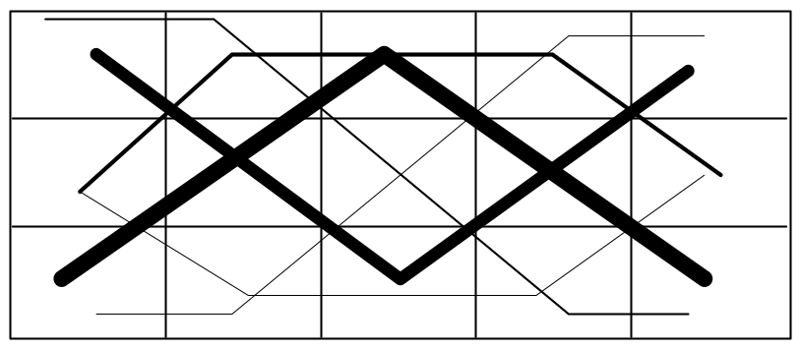
1.
2.
3.
4.
5.
6.
1
3
2
PROBLEM: The ACSL-SLOT machine is a video game with some interesting properties. Whereas some slot machines display fruits, numbers or icons, the ACSL machine displays binary digits. Whereas some machines determine a winner by having winners only on a horizontal line, the ACSL winners follow the 6 patterns above. Winners are determined when 3 or more adjacent 1's appear on any of the patterns. The amount won is determined by the following table:

3 adjacent 1's in any given pattern | Twice the amount bet
4 adjacent 1's in any given pattern | Three times the amount bet
5 adjacent 1's in any given pattern | Four times the amount bet
INPUT: There will be 12 lines of input. The 1st and 7th input lines will contain a 6-digit string giving the starting row number ( note the row numbers to the right of the grid) of each pattern - the order is as shown above, the integer amount bet and a 7- digit hexadecimal value. You will need to convert the hex value to a 28-digit binary value. Delete the 3 right-most digits and place the remaining 25 digits into a 5 x 5 array, starting at the upper left and going across the rows. Input lines 2 - 6 will be used with input line 1 and input lines 8 - 12 will be used with input line 7. These lines will give the pattern to use. Note that in Sample Input #3 the number 2 pattern starts in row 5 and in Sample Input #11 the number 5 pattern starts in row 3. We guarantee the starting row number will keep each pattern on the grid.

OUTPUT: For each input line, print the amount won.

SAMLE INPUT SAMPLE OUTPUT
1. 353515, 50, EEFCEE0 1. 100
2. 1 2. 150
3. 2 3. 150
4. 4 4. 0
5. 5 5. 150
6. 6 6. 0
7. 122535, 10, A9BCDE1 7. 20
8. 2 8. 20
9. 3 9. 20
10. 4 10. 30
11. 5
12. 6

ACSL
American Computer Science League
008 -2013 - 2014
All-Star #6
ACSL-Slots
TEST DATA

TEST INPUT TEST OUTPUT
1. 121323, 20, FEDCBA0 1. 80
2. 5 2. 40
3. 4 3. 80
4. 3 4. 80
5. 2 5. 0
6. 1 6. 200
7. 242445, 50, 07DEF78 7. 150
8. 1 8. 200
9. 2 9. 150
10. 3 10. 150
11. 4
12. 5

